SQL ASSIGNMENT 2

Avinash A Godi



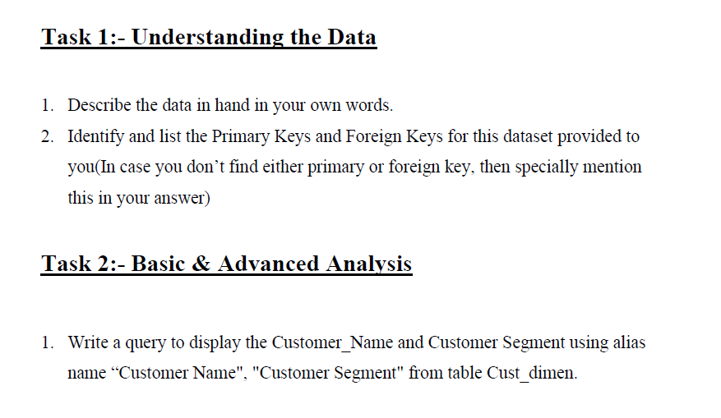

**---- Task 1 Understanding the Data ----**

**/* 1. Describe the data in hand in your own words.**

This database contains Sales details of transaction of a superstores. The structure has 5 tables

**Table 1.** cust_dimen (containing details about customer and their respective locations, contains 5 columns and 1833 rows)

**Column 1.** Customer_Name (TEXT): Name of the customer

**Column 2.** Province (TEXT): Province of the customer

**Column 3.** Region (TEXT): Region of the customer

**Column 4.** Customer_Segment (TEXT): Segment of the customer

**Column 5.** Cust_id (TEXT): Unique Customer ID

**Table 2.** prod_dimen (containing product category, product subcategories, and product id contains 3 columns and 18 rows)

**Column 1.** Product_Category (TEXT): Product Category

**Column 2.** Product_Sub_Category (TEXT): Product Sub Category

**Column 3.** Prod_id (TEXT): Unique Product ID

**Table 3.** orders_dimen (containing order no, order date, order priority, and order id contains 4 columns and 5507 rows)

**Column 1.** Order_ID (INT): Order ID

**Column 2.** Order_Date (TEXT): Order Date

**Column 3.** Order_Priority (TEXT): Priority of the Order

**Column 3.** Ord_id (TEXT): Unique Order ID

**Table 4.** shipping_dimen (containing ship date, order and shipping mode contains 4 columns and 7702 rows)

**Column 1.** Order_ID (INT): Order ID

**Column 2.** Ship_Mode (TEXT): Shipping Mode

**Column 3.** Ship_Date (TEXT): Shipping Date

**Column 4.** Ship_id (TEXT): Unique Shipment ID

**Table 5.** market_fact (containing orderwise customerwise marketwise orderquantity, sales value, discount profit and shipping cost details contains 10 columns and 8400 rows).

**Column 1.** Ord_id (TEXT): Order ID

**Column 2.** Prod_id (TEXT): Prod ID

**Column 3.** Ship_id (TEXT): Shipment ID

**Column 4.** Cust_id (TEXT): Customer ID

**Column 5.** Sales (DOUBLE): Sales from the Item sold

**Column 6.** Discount (DOUBLE): Discount on the Item sold

**Column 7.** Order_Quantity (INT): Order Quantity of the Item sold

**Column 8.** Profit (DOUBLE): Profit from the Item sold

**Column 9.** Shipping_Cost (DOUBLE): Shipping Cost of the Item sold

**Column 10.** Product_Base_Margin (DOUBLE): Product Base Margin on the Item sold */

**/* 2. Identify and list the Primary Keys and Foreign Keys for this dataset provided to you(In case you don’t find either primary or foreign key, then specially mention this in your answer)**

**Table 1.** cust_dimen

Primary Key: Cust_id

Foreign Key: NA

**Table 2.** prod_dimen

Primary Key: Prod_id, Product_Sub_Category

Foreign Key: NA

**Table 3.** orders_dimen

Primary Key: Ord_id

Foreign Key: NA

**Table 4.** shipping_dimen

Primary Key: Ship_id

Foreign Key: NA

**Table 5.** market_fact

Primary Key: NA

Foreign Key: Ord_id, Prod_id, Ship_id, Cust_id */

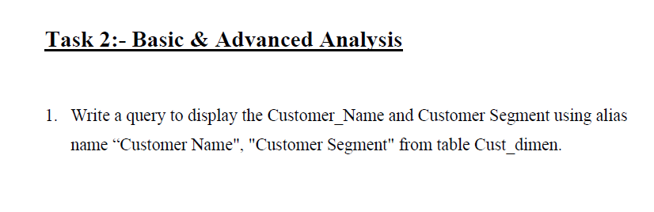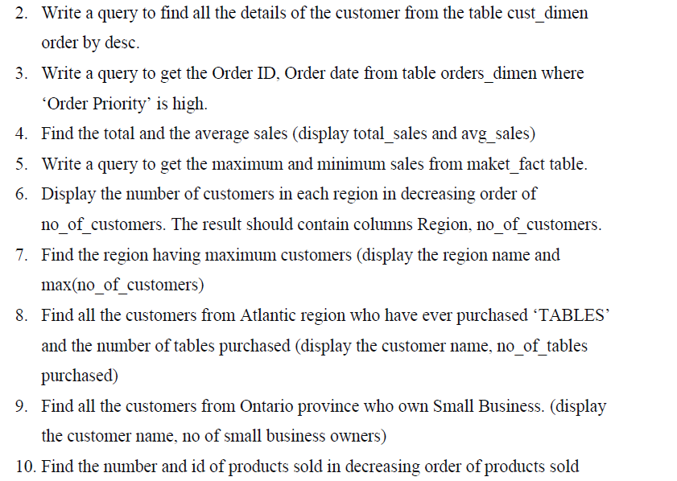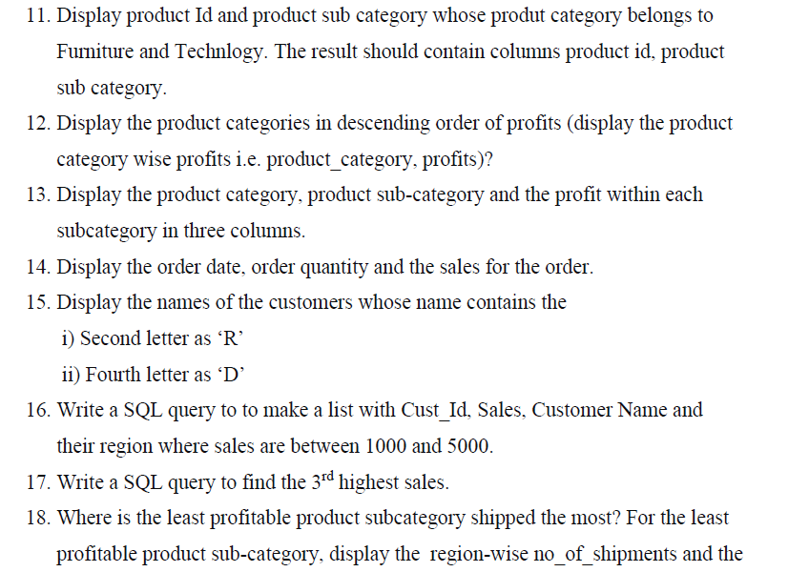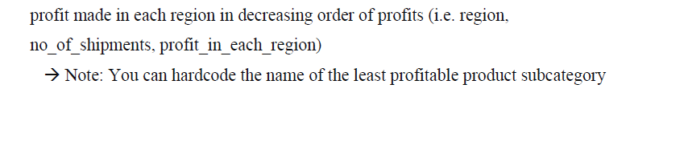

**---- Task 2. Basic & Advanced Analysis ----**

**/* 1. Write a query to display the Customer_Name and Customer Segment using alias name “Customer Name", "Customer Segment" from table Cust_dimen**. */

select Customer_Name as 'Customer Name', Customer_Segment as 'Customer Segment' from superstores.cust_dimen;

**/* 2. Write a query to find all the details of the customer from the table cust_dimen order by desc. */**

select * from superstores.cust_dimen order by Customer_Name desc;

**/* 3. Write a query to get the Order ID, Order date from table orders_dimen where ‘Order Priority’ is high. */**

select Ord_id as 'Order ID', Order_Date as 'Order Date', Order_Priority from superstores.orders_dimen where Order_Priority like 'HIGH';

**/* 4. Find the total and the average sales (display total_sales and avg_sales) */**

select round(sum(Sales),2) as 'Total Sales', round(avg(Sales),2) as 'Average Sales' from superstores.market_fact;

**/* 5. Write a query to get the maximum and minimum sales from maket_fact table. */**

select max(Sales) as 'Maximum Sales', min(Sales) as 'Minimum Sales' from superstores.market_fact;

**/* 6. Display the number of customers in each region in decreasing order of no_of_customers. The result should contain columns Region, no_of_customers. */**

select Region, count(*) as 'No_of_customers' from superstores.cust_dimen group by Region order by No_of_customers desc;

**/* 7. Find the region having maximum customers (display the region name and max(no_of_customers). */**

select Region, count(*) as 'No_of_customers' from superstores.cust_dimen group by Region order by No_of_customers desc limit 1;

**/* 8. Find all the customers from Atlantic region who have ever purchased ‘TABLES’ and the number of tables purchased (display the customer name, no_of_tables purchased). */**

select Customer_Name, count(*) as 'No_of_tables' from superstores.cust_dimen c, superstores.market_fact m, superstores.prod_dimen p where c.Cust_id=m.Cust_id and m.Prod_id=p.Prod_id and Region like 'ATLANTIC' and Product_Sub_Category like 'TABLES' group by Customer_Name;

**/* 9. Find all the customers from Ontario province who own Small Business. (display the customer name, no of small business owners). */**

select Customer_Name as 'Customer Name', Customer_Segment as 'No. of Customer Segment', Province from superstores.cust_dimen where Province like 'Ontario' and Customer_Segment like 'small business';

**/* 10. Find the number and id of products sold in decreasing order of products sold (display product id, no_of_products sold). */**

select Prod_id, sum(Order_Quantity) as "no_of_products sold" from superstores.market_fact group by Prod_id order by sum(Order_Quantity) DESC;

**/* 11. Display product Id and product sub category whose produt category belongs to Furniture and Technlogy. The result should contain columns product id, product sub category. */**

select Prod_id as 'Product ID', Product_Sub_Category as 'Product Sub Category', Product_Category as 'Product Category' from superstores.prod_dimen where Product_Category like 'TECHNOLOGY' or Product_Category like 'FURNITURE';

**/* 12. Display the product categories in descending order of profits (display the product category wise profits i.e. product_category, profits)? */**

select Product_Category as 'Product Category', round(sum(Profit),2) as 'Profits' from superstores.prod_dimen p, superstores.market_fact m where m.Prod_id = p.Prod_id group by Product_Category order by sum(Profit) desc;

**/* 13. Display the product category, product sub-category and the profit within each subcategory in three columns. */**

select Product_Category as 'Product Category', Product_Sub_Category as 'Product Sub Category', round(sum(Profit),2) as 'Profits' from superstores.prod_dimen p, superstores.market_fact m where m.Prod_id = p.Prod_id group by Product_Sub_Category order by Product_Category;

**/* 14. Display the order date, order quantity and the sales for the order. */**

select Order_Date, Order_Quantity, Sales from superstores.orders_dimen o, superstores.market_fact m where m.Ord_id = o.Ord_id order by order_quantity desc;

**/* 15. Display the names of the customers whose name contains the */**

**/* i) Second letter as ‘R’ */**

select Customer_Name from superstores.cust_dimen where Customer_Name like '_r%';

**/* ii) Fourth letter as ‘D’ */**

select Customer_Name from superstores.cust_dimen where Customer_Name like '___d%';

**/* 16. Write a SQL query to to make a list with Cust_Id, Sales, Customer Name and their region where sales are between 1000 and 5000. */**

select c.Cust_id, Sales, Customer_Name as 'Customer Name', Region from superstores.cust_dimen c, superstores.market_fact m where m.Cust_id = c.Cust_id and Sales between 1000 and 5000;

**/* 17. Write a SQL query to find the 3rd highest sales. */**

select Sales as 'Third Highest Salary' from superstores.market_fact order by Sales desc limit 2,1;

**/* 18. Where is the least profitable product subcategory shipped the most? For the least profitable product sub-category, display the region-wise no_of_shipments and the profit made in each region in decreasing order of profits (i.e. region, no_of_shipments, profit_in_each_region)**

**Note: You can hardcode the name of the least profitable product subcategory */**

select c.Region as "Region",count(m.Ship_id) as "No of Shipments", round(sum(m.Profit),2) as "Profit in each region"

from superstores.market_fact m

join superstores.cust_dimen c on m.Cust_id = c.Cust_id

join superstores.prod_dimen p on m.Prod_id = p.Prod_id

Where Product_Sub_Category = (Select p.Product_Sub_Category from superstores.market_fact m join superstores.prod_dimen p on m.Prod_id = p.Prod_id group by Product_Sub_Category order by sum(m.Profit) LIMIT 1)

group by c.Region

order by sum(m.Profit);